Notes 4

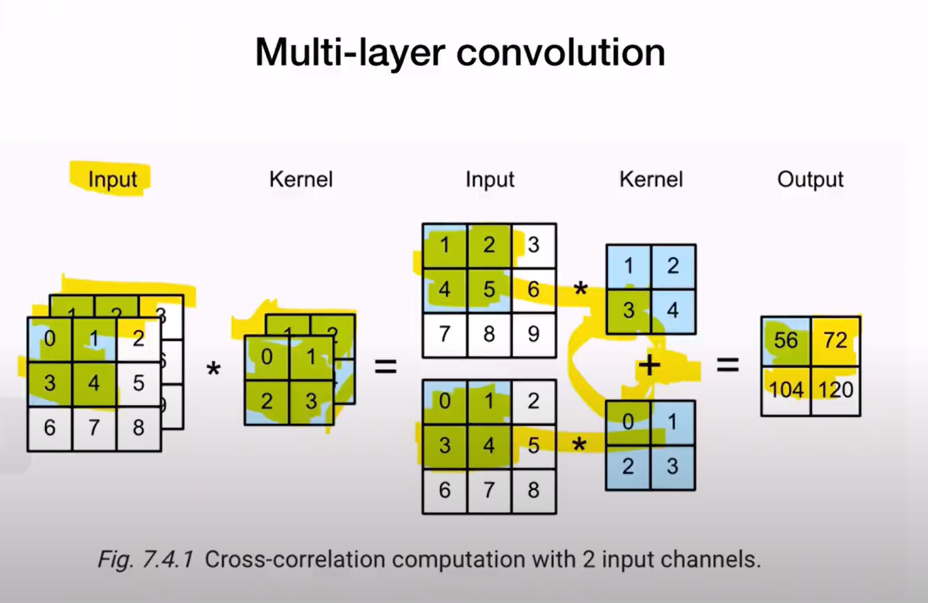



If the input is multiple channels, then kernel will also be of same depth and it will span the entire depth of the input and result in one output channel

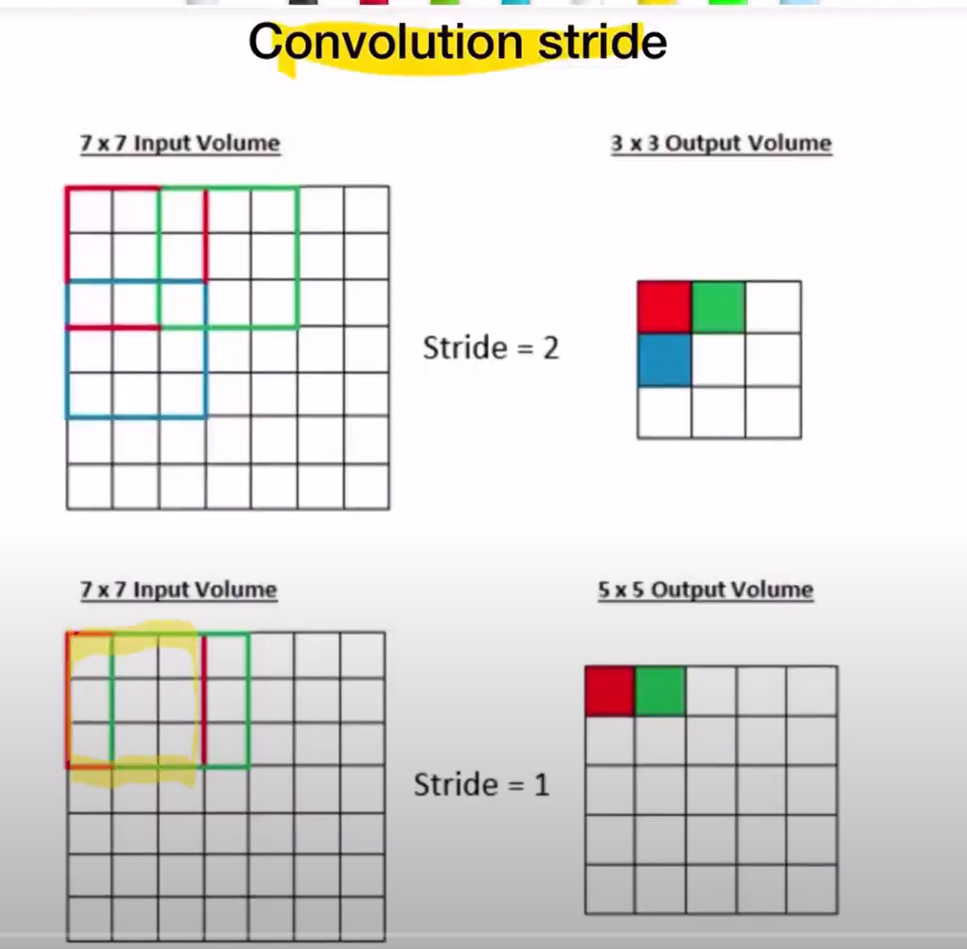

Stride helps in reducing the image size. A reduced image gives the summary of the picture instead of more spatial information

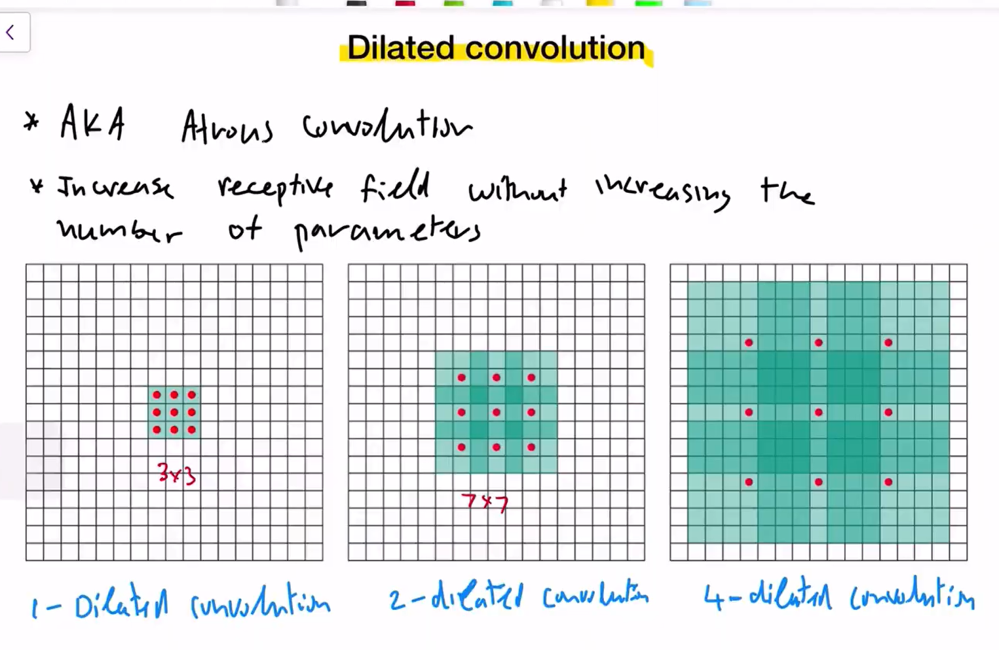

When we generally increase the kernel size( for larger pattern matching, the computational cost is higher. Because we multiply more numbers for each position.

To reduce the computation, we use dilated convolution where the kernel values are spaced. In 3x3, there is no dilation, all the 9 spots have values. In 7x7, instead of 49 values, the values are spaced by 2 spots (every 2nd spot has a value) having only 9 values on the whole🡪2 dilated. Similarly, the last 15x15 is 4 dilated with 4 empty spots between values resulting in 9 values. Weighted sum of all red dot locations is used.

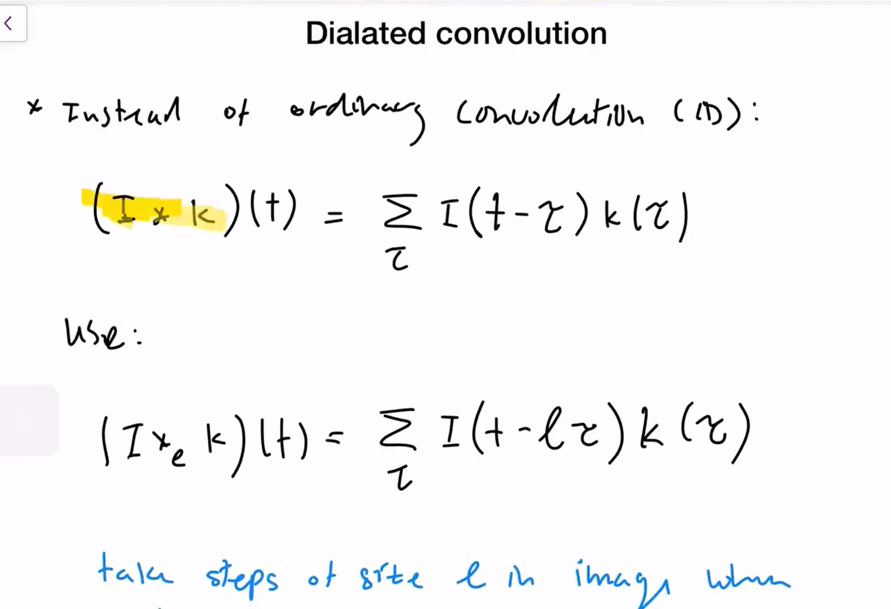



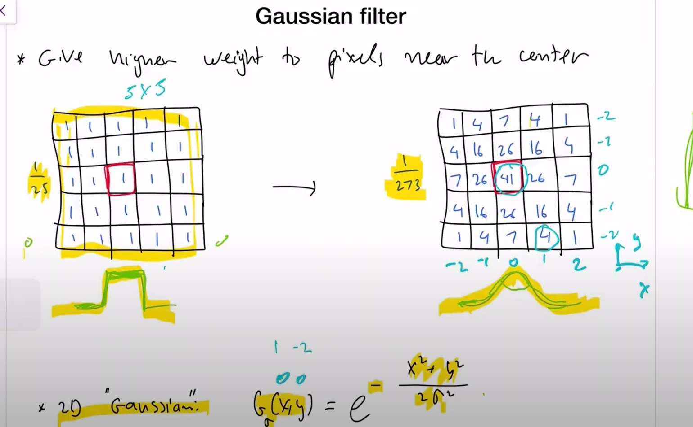



Gaussian filter for smoothing -

The filter on the left has sharp edges and so, we use exponential function to change the signal Gaussian.

273🡪sum of all values in the cells 🡪divided to maintain the intensity

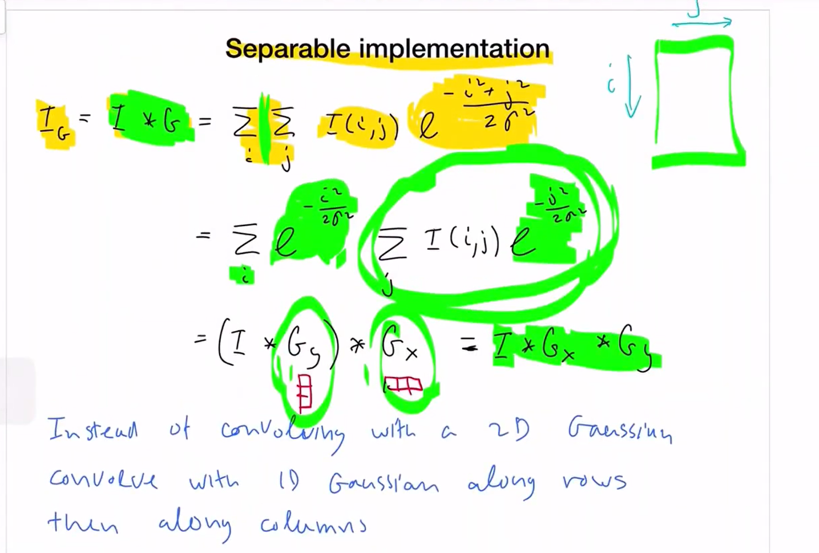

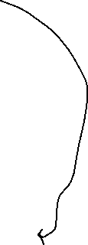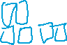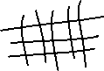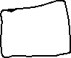

Instead of moving the entire kernel through the image for convolution, we separate the filter as row wise and column wise to do the convolution separately as 1d convolution.

For eg – the blue convolution is done first and then the orange convolution is done on the blue’s result. The two consecutive 1d convolution will still result in the same output as 2d convolution

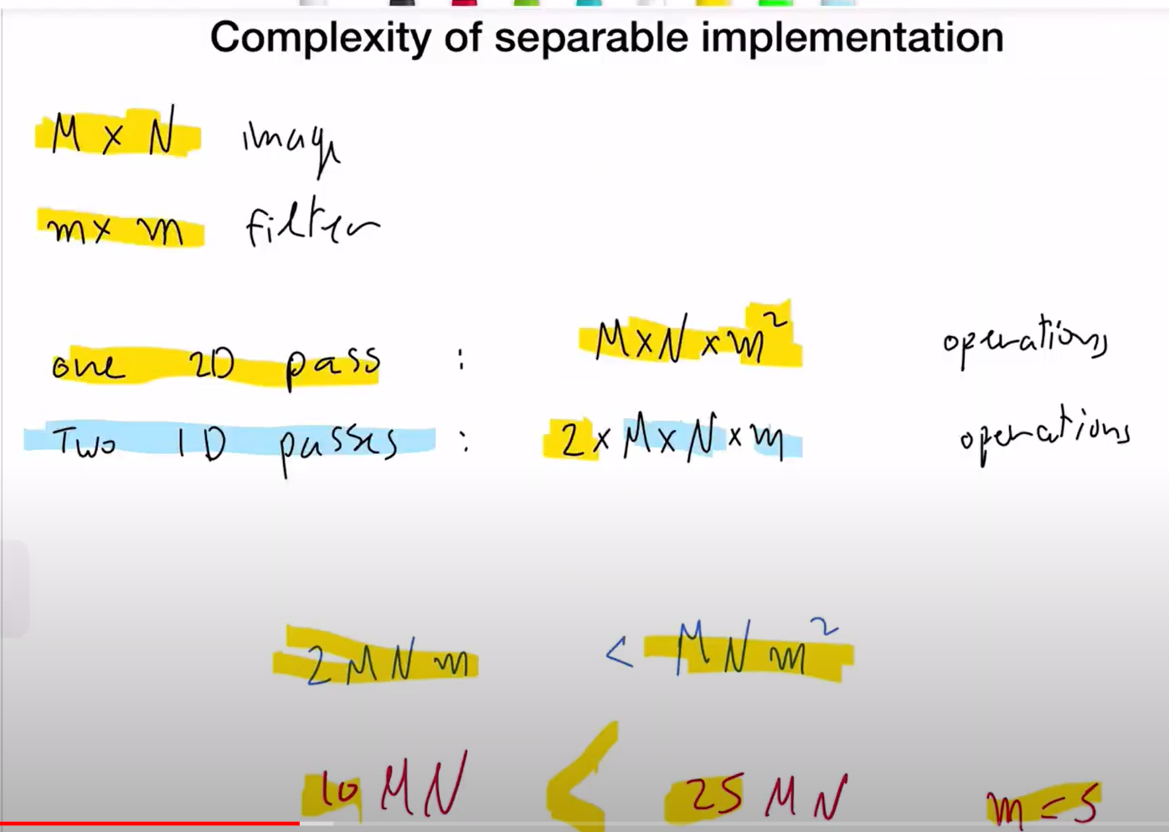

The separable convolution helps to reduce computation thereby increasing the speed of network and learning and faster output

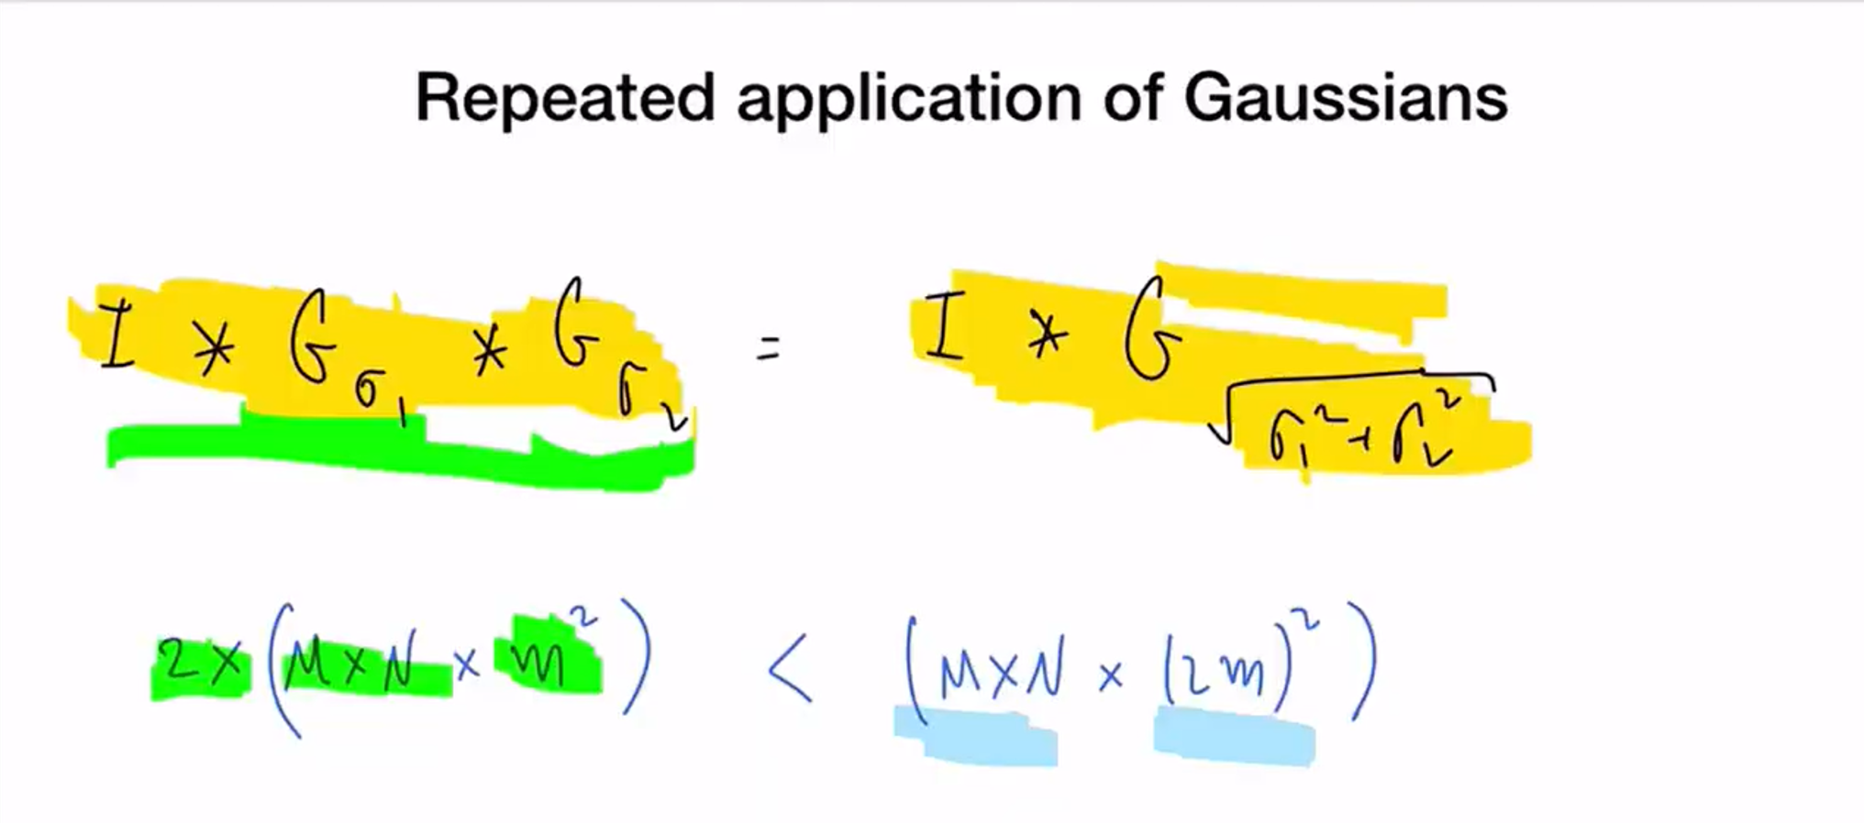

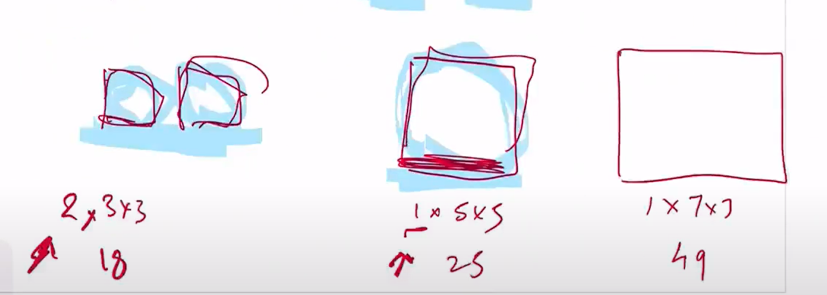

For Gaussian, the values will be same for both methods. However, computation wise, it will be better to do multiple smaller convolutions than doing one conv with bigger sigma.

How to select the Gaussian variance-🡪the bigger the sigma value is, the bigger the value of filter should be….The std should be less than or equal to filter size/5

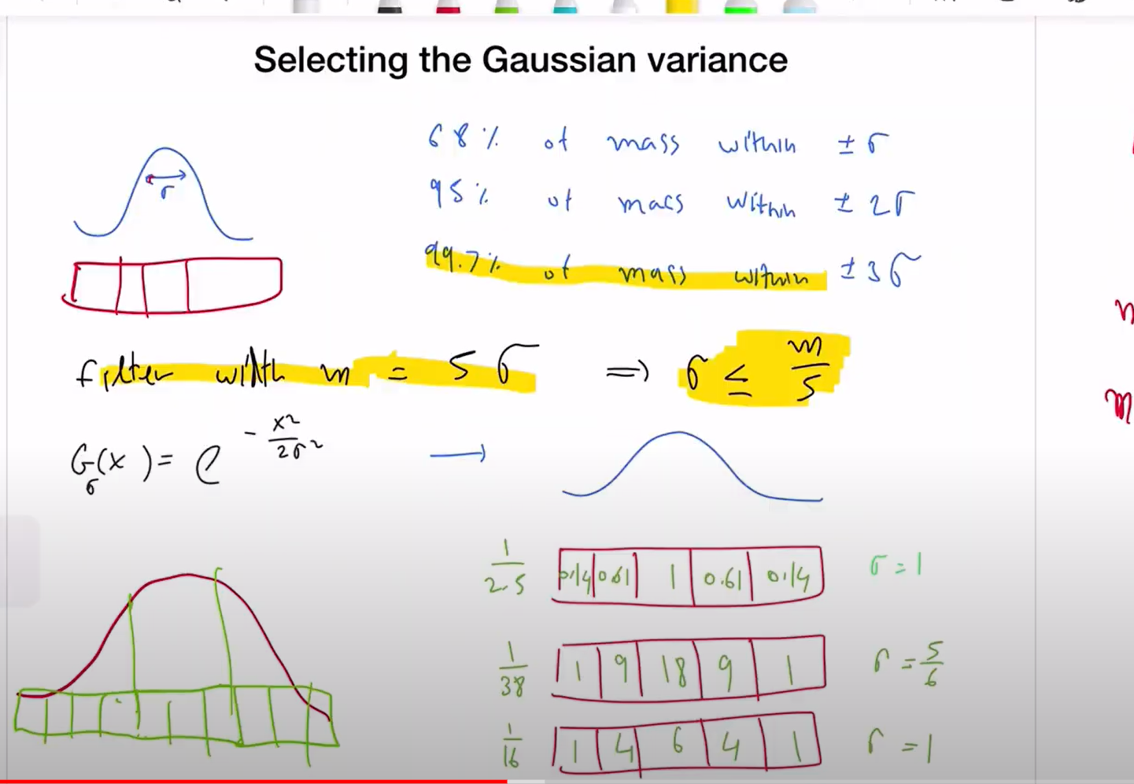



To cover fully (99%),3 times sigma is used….



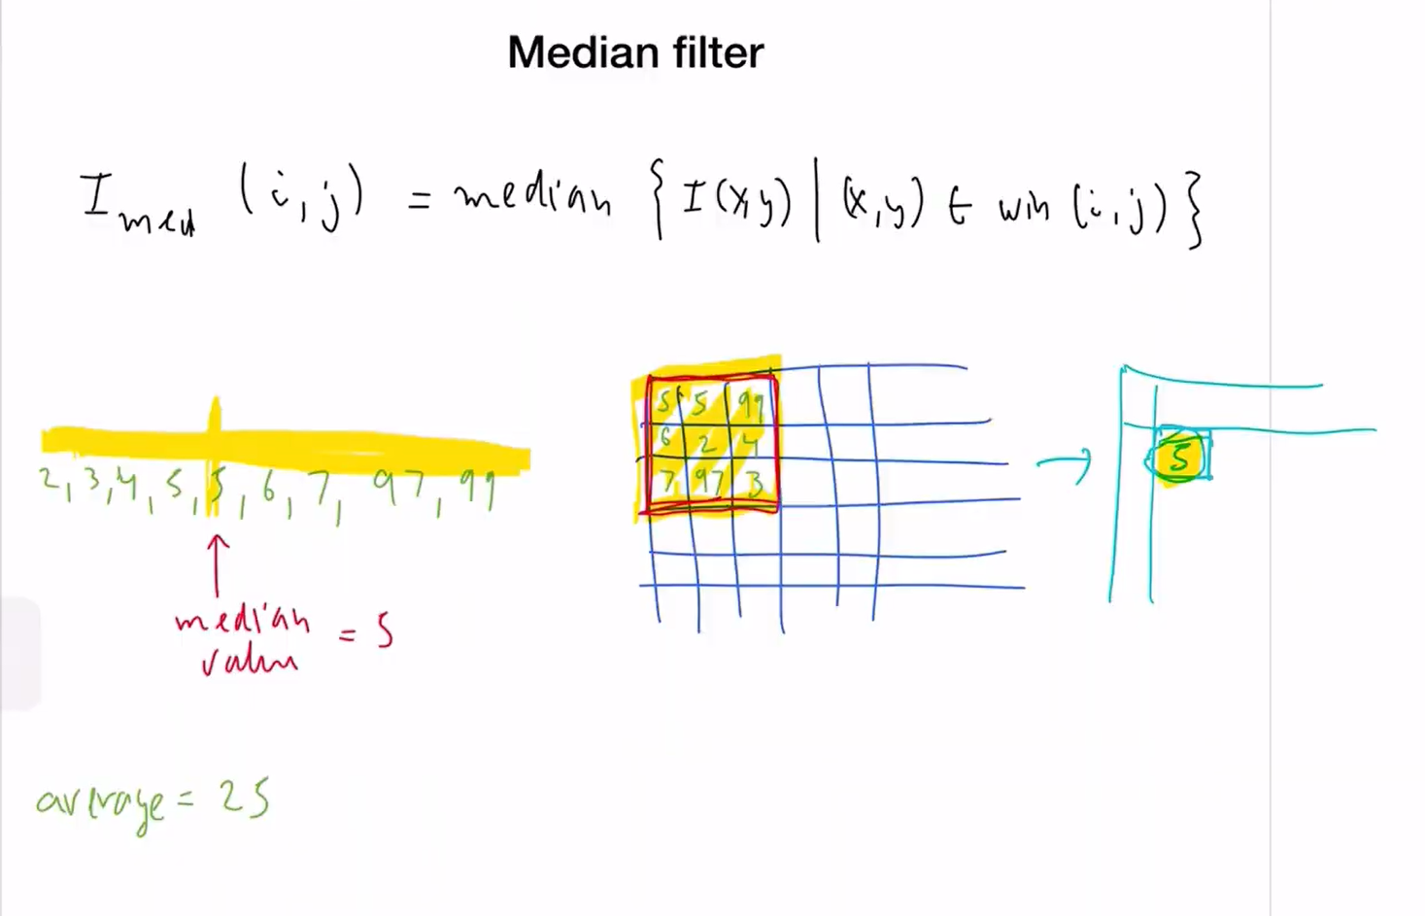

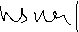

Instead of taking the weighted sum as in convolution , we pick a single media value from the cells over which the filter is placed and the result written at center as usual

Median filter helps in avoiding the outliers (like 97,99 here).

Median mostly used in pre processing and not in regular network type filters

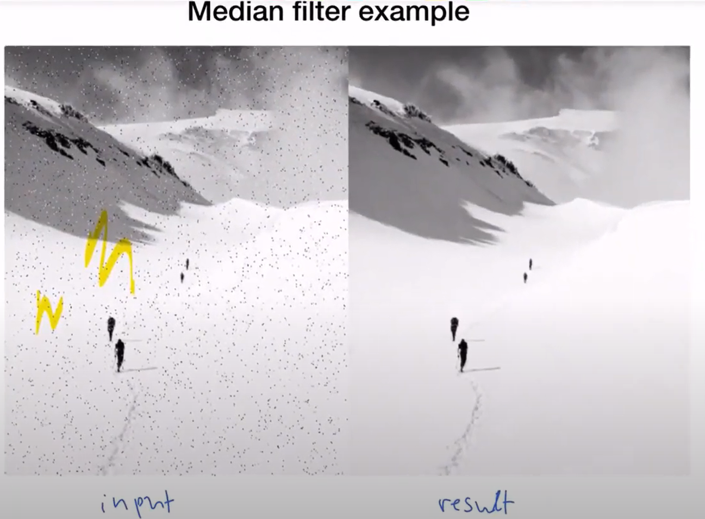

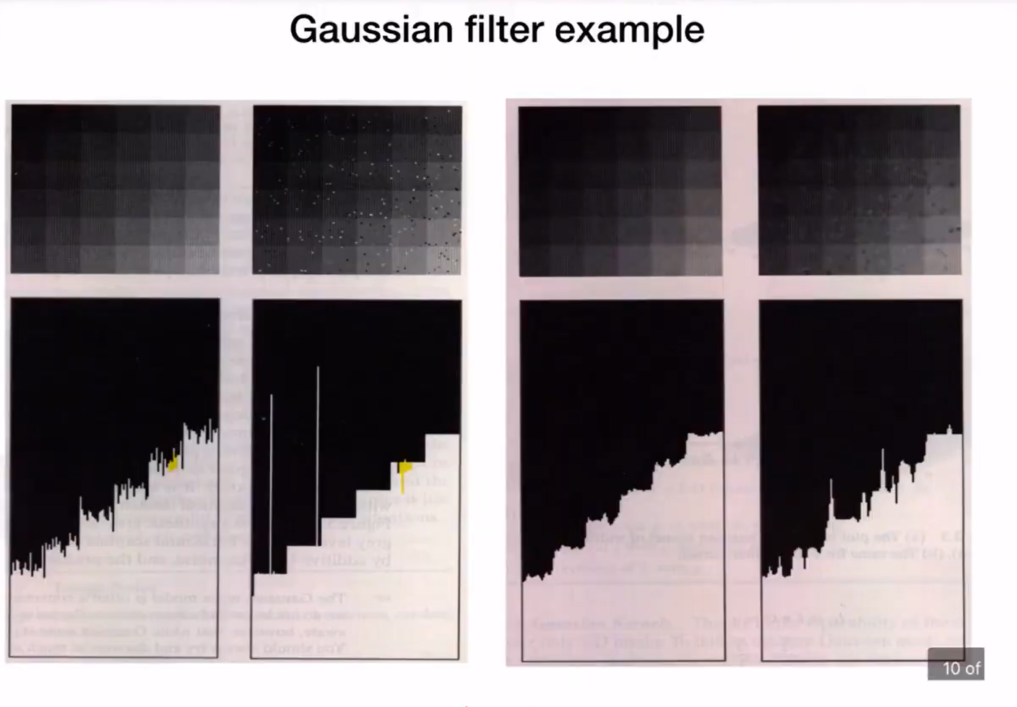



Gaussian i/p is smoothened but the impulsive (salt&pepper)i/p 🡪the output spreads the noise as we took average in th efilter

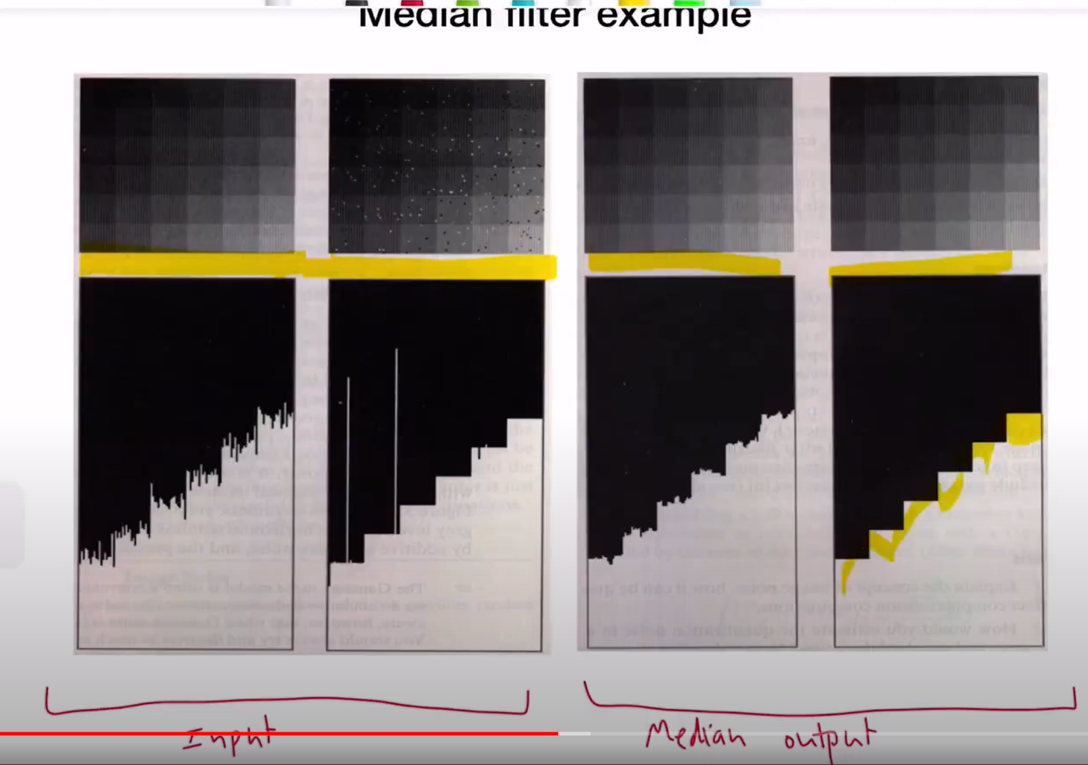

Median has better result for both Gaussian and impulsive inputs

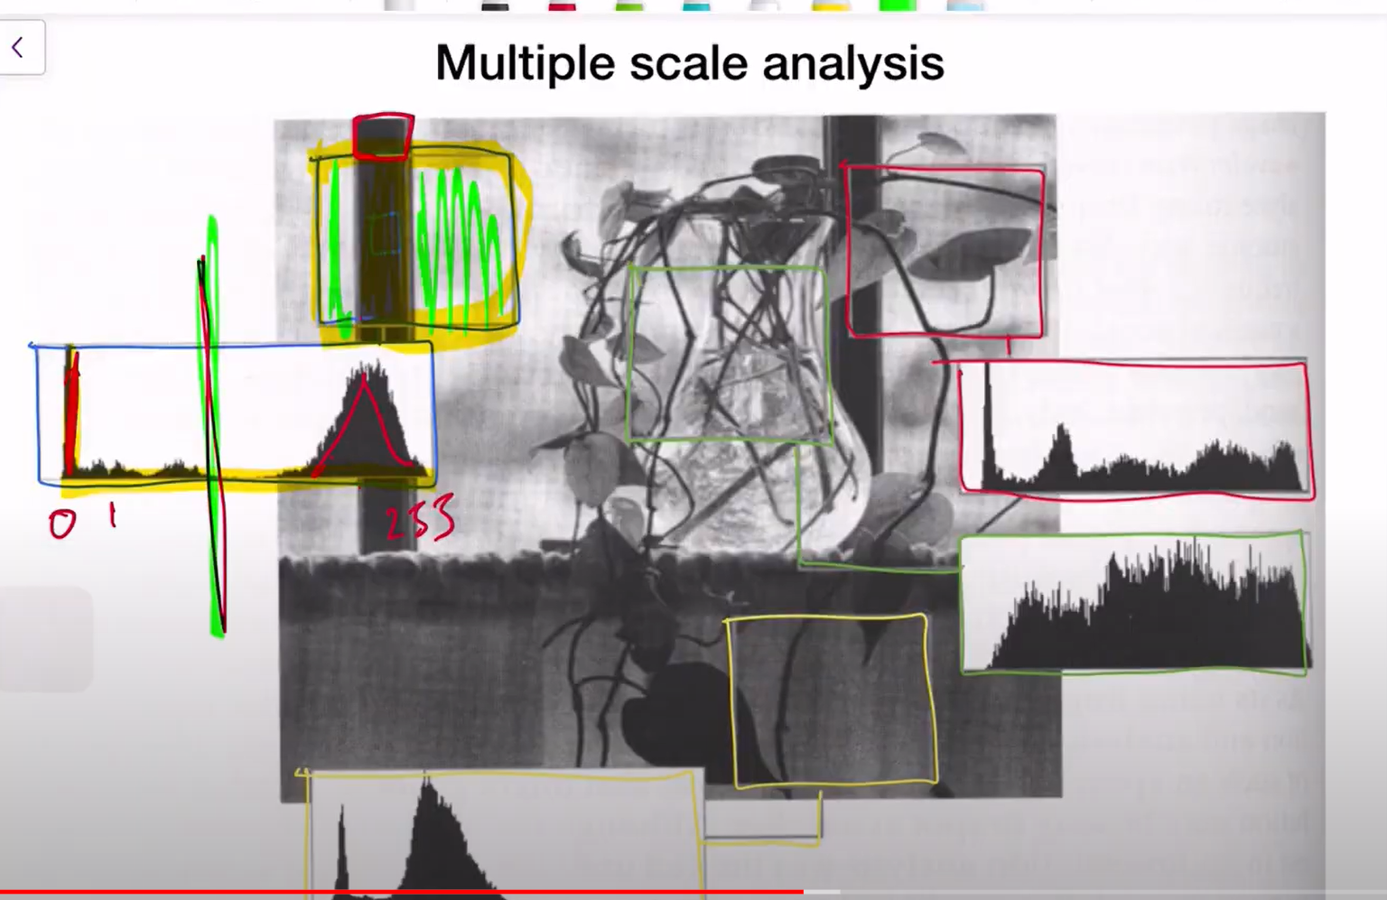

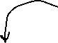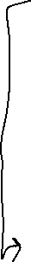

Separation of fore ground and background. We take a window and then plot histogram with values as x axis and the number of pixels with that value in y axis.

This is a histogram , where there are 2 peaks , at 0 and at 255. The 0 corresponds to the black vertical wall/something in the picture and 255 corresponds to the background(white)

This analysis helps with the right window size. But, how do we choose the right window?

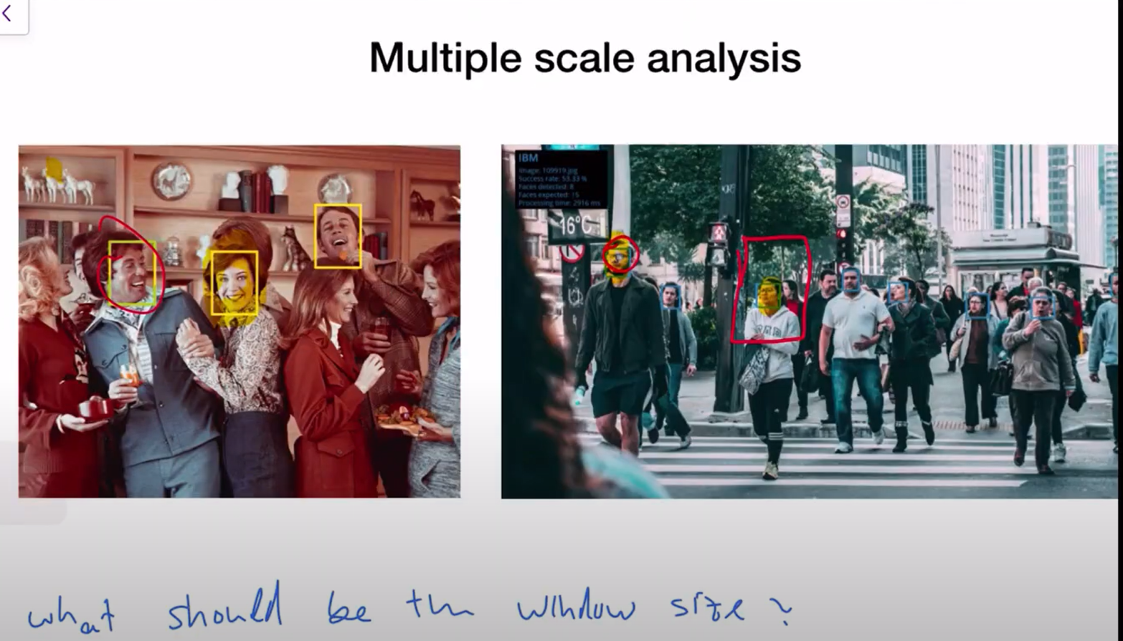

Here, for first picture, a rectangle window of medium size may be needed, but the same cannot be used on the next picture, because the people are far in the image and it would need a smaller window size.

To overcome the issue, we use multiple windows of different sizes.

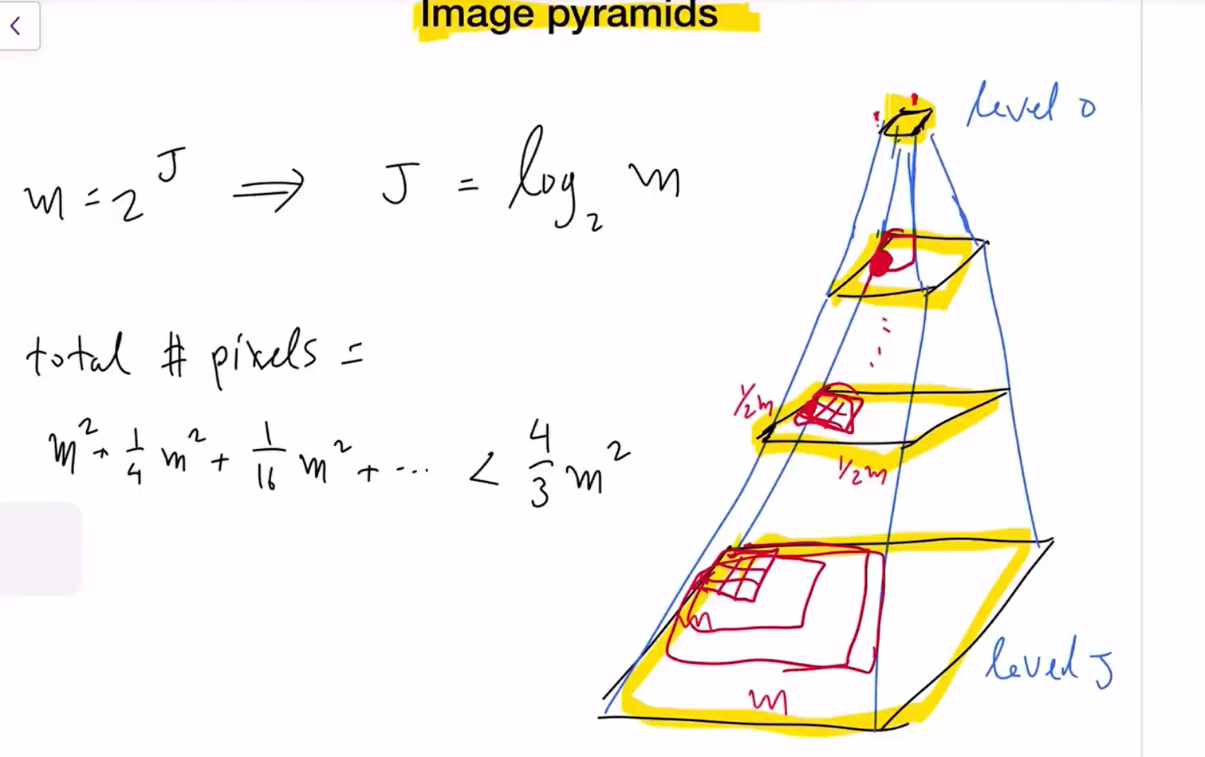



We take the mxm image, sample it(meaning take every 2nd value and make a matrix)---as 2nd level,

Keep sampling🡪get to the next scale.

This sampling helps to give a overview of a larger area with a less values. That is, every pixel in level 2 was the second pixel in original image (level 3) and therefore the 3x3 window in level 2 is actually the 6x6 window in the level 3. A smaller filter at the top of the pyramid covers a lot of the original image

On the whole of building the pyramid , we only get the number of values/cell elements increased to a less than 4/3 (m^2)…which is like an additional 30% of computation give me layers of understanding of the image

Disadvantage🡪sampling is like quantization🡪more sampling cause more aliasing

To avoid aliasing, we smoothen the image by convolving with gaussian and then take sample (pooling)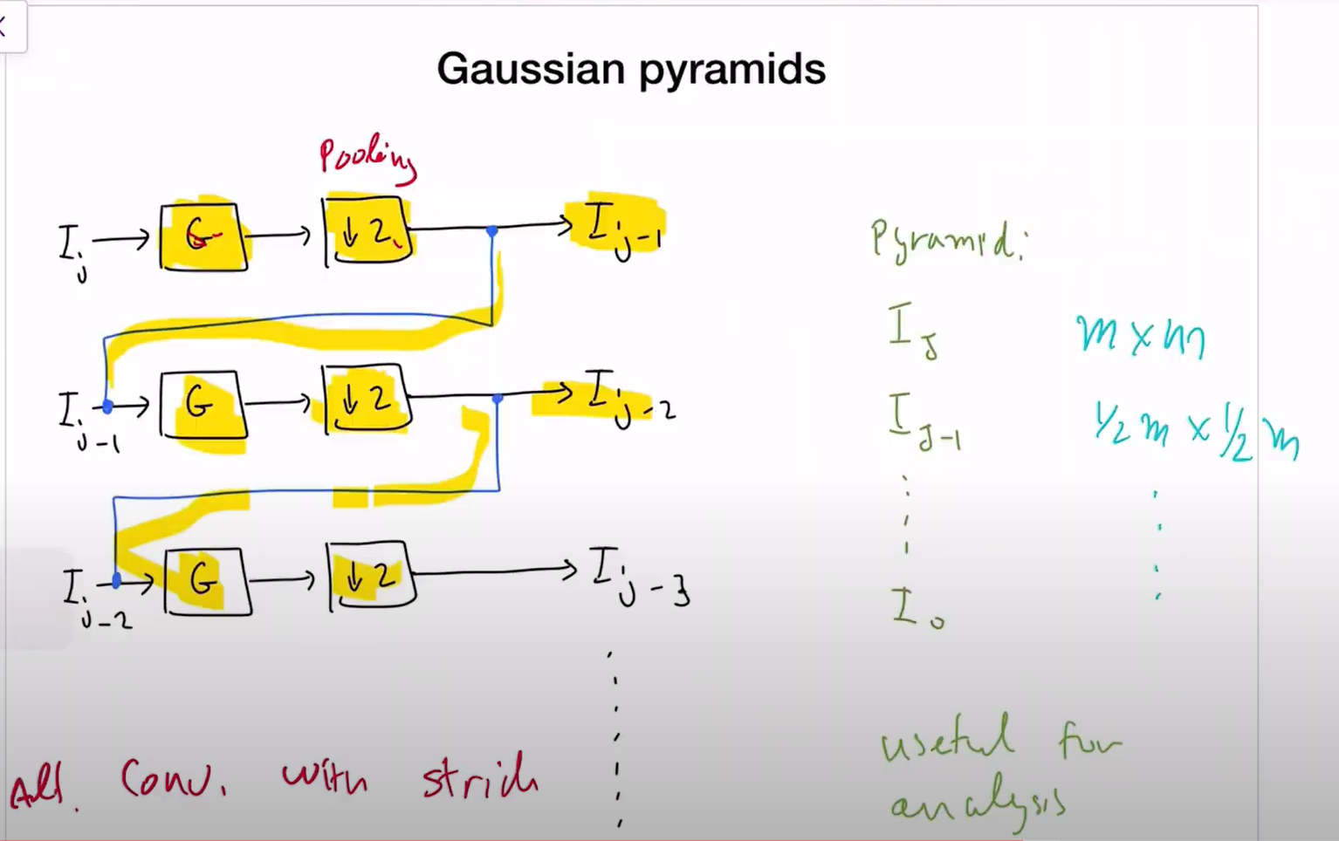

The filter can be any (based on the n/w learning) but for theory sampling, Gaussian is used

Instead of convolving and then sampling, we can also convolution with stride directly to reduce the image size in half.

All the sampled image matrices are plotted in the same dimensions. We see that as

we move right, the more sampled images have lesser details and are blurred but gives a larger reception of image.

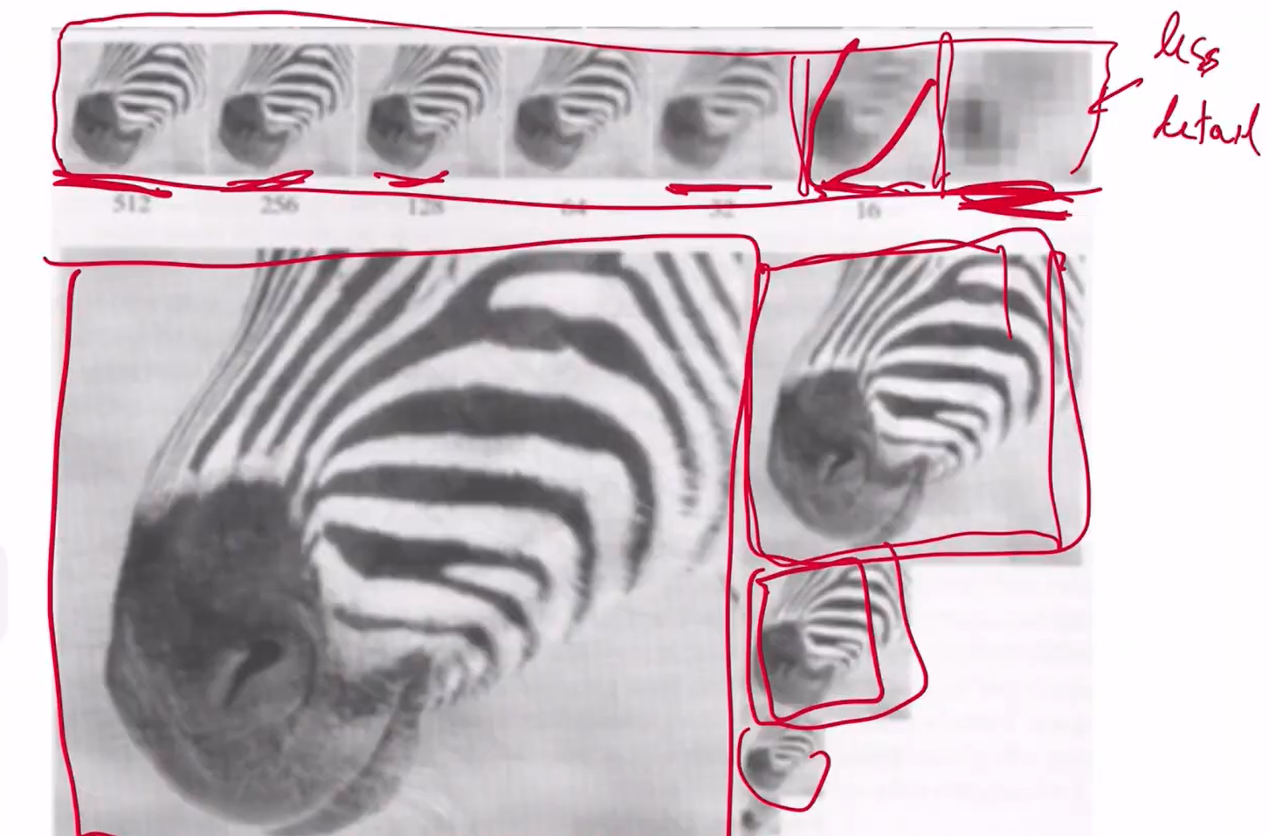

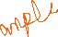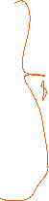

Characteristics of pyramid -> better reception/overview at the top of the pyramid and lesser details.

Gaussian pyramid - Use for analysis

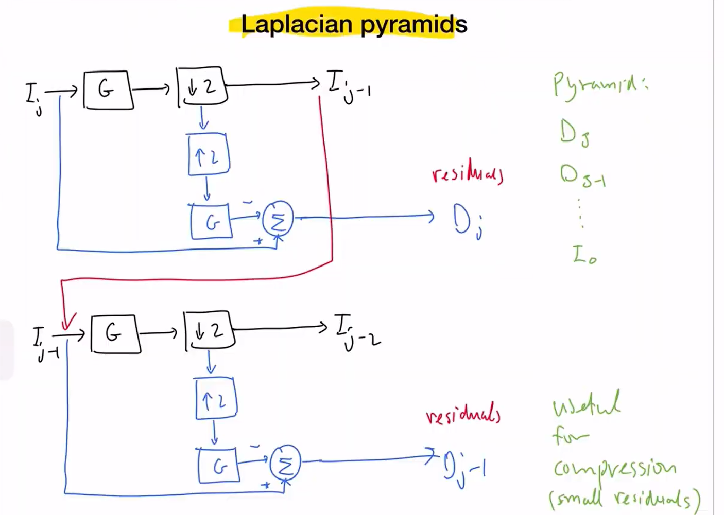

Here,we take the image,smoothen, down sample and then up sample to get back to the original resolution(duplicate the pixels)🡪more pixelated🡪aliasing🡪smoothen again (G) and then compare with the original image to see how much info is lost due to these processses and that diff is residuals.

We can repeat the same for multiple time by taking the down sampled image for next layer. Ideally, It is just the same as the Gaussian pyramid, but we just want to see the sampled image in th eoriginal size for better view, so we upsample and then smoothen again for viewing

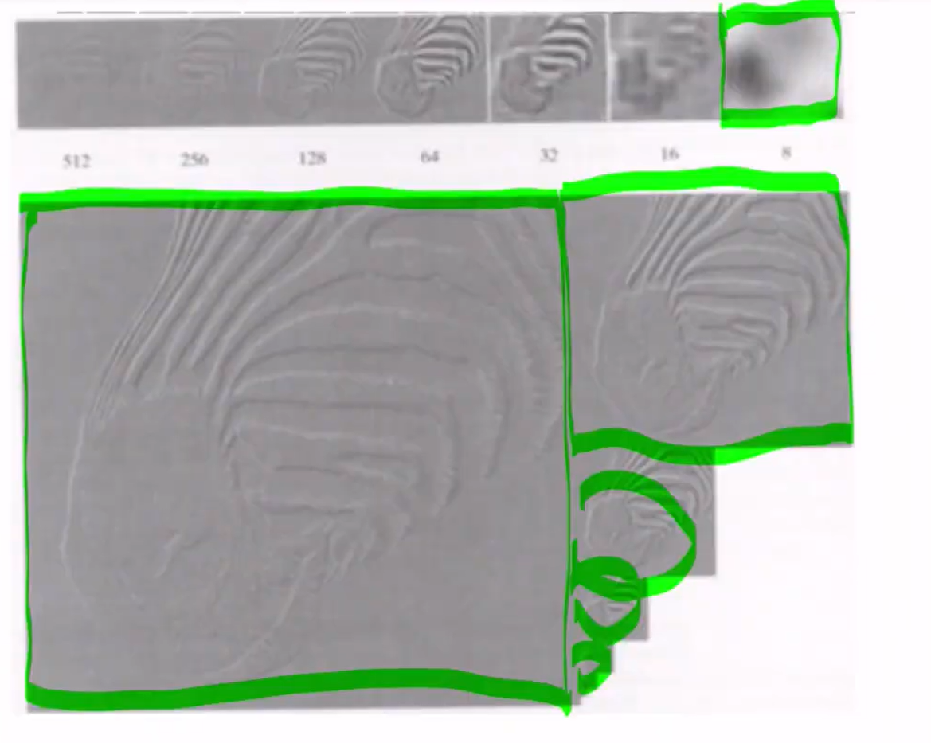

The above is the plots of the residuals and not the image itself. This shows where the differences are, due to these processes(this shows where the mistakes happen) 🡪the mistakes are mostly when there is transitions between the black and white (where there are more details)

Advantage 🡪we can construct the original image back by addding the error and upsampling at each level . We store the residuals in all the levels and the final image so that we can construct the original backwards.

Laplacian pyamid - > not used for analysis but for image comparison

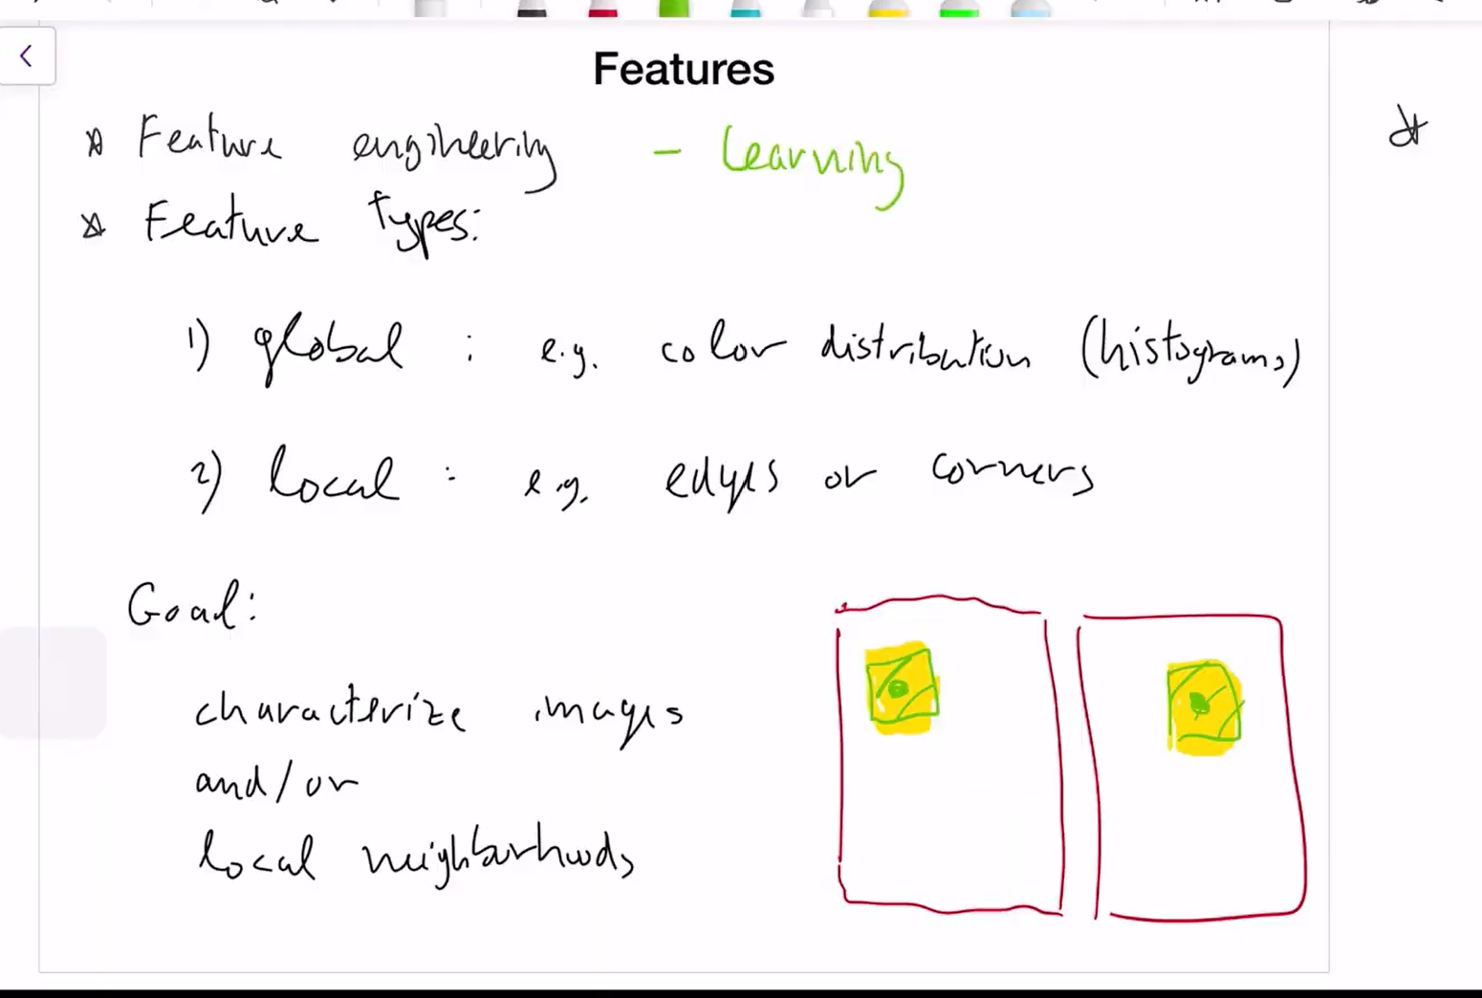



Feature engineering - we give the features to look at/extract

Feature Learning – The n/w learns by itself.

Global – summary of the entire image – histogram - trying to match up similar images by characterizing the while image

Local - trying to find details in an image

